Scatter Graphs-Answers
Key Stage 3: 2003 Paper 1 Level 5-7
1.
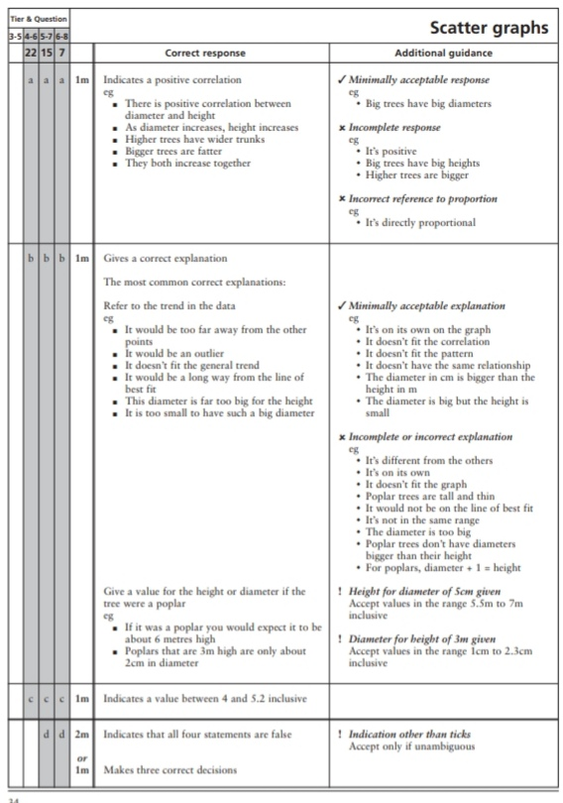
Key Stage 3: 2003 Paper 1 Level 6-8
2.
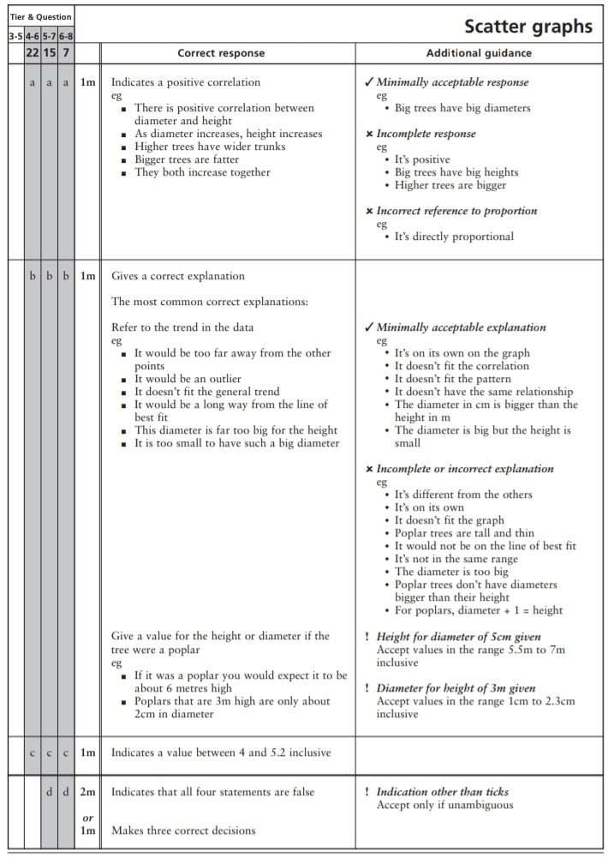
Key Stage 3: 2004 Paper 1 Level 5-7
3.
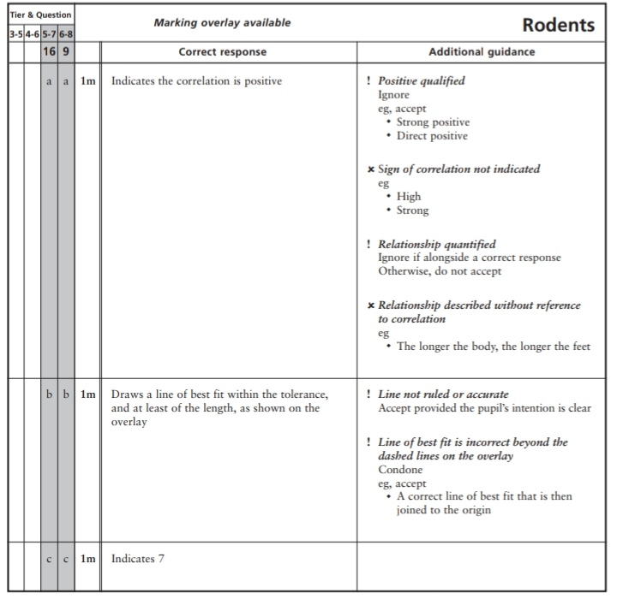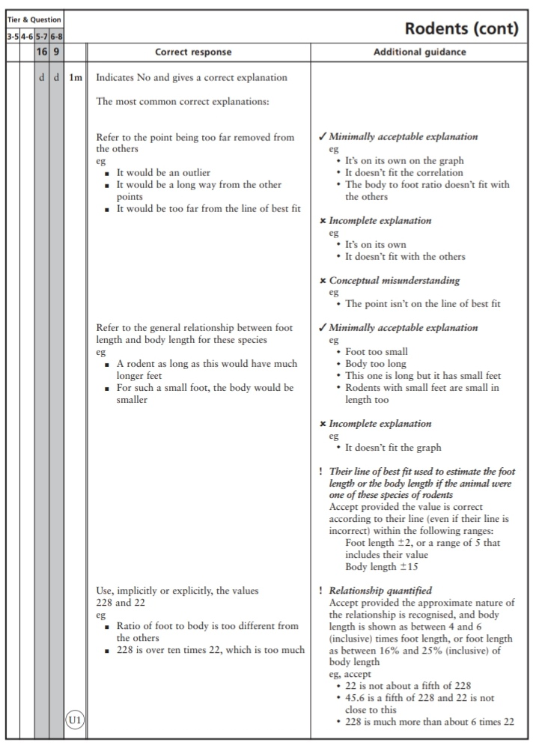
Key Stage 3: 2004 Paper 1 Level 6-8
4.
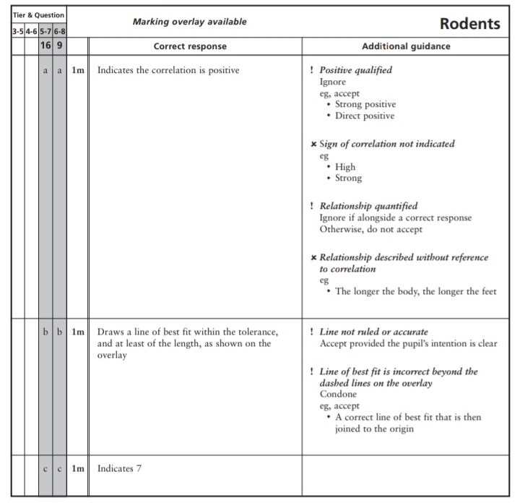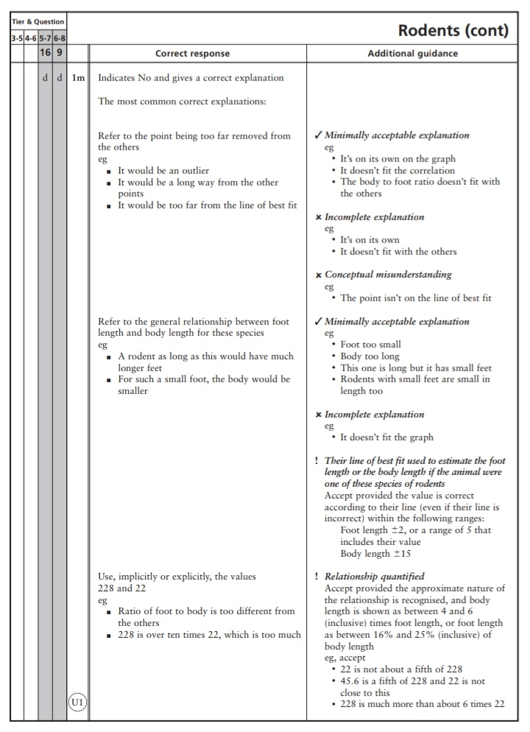
Key Stage 3: 2005 Paper 1 Level 5-7
5.
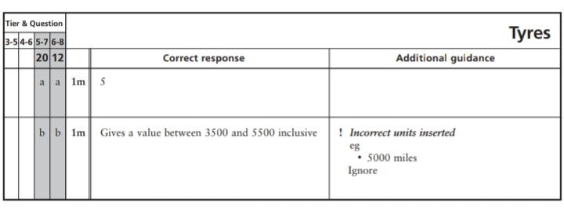
Key Stage 3: 2006 Paper 1 Level 5-7
6.
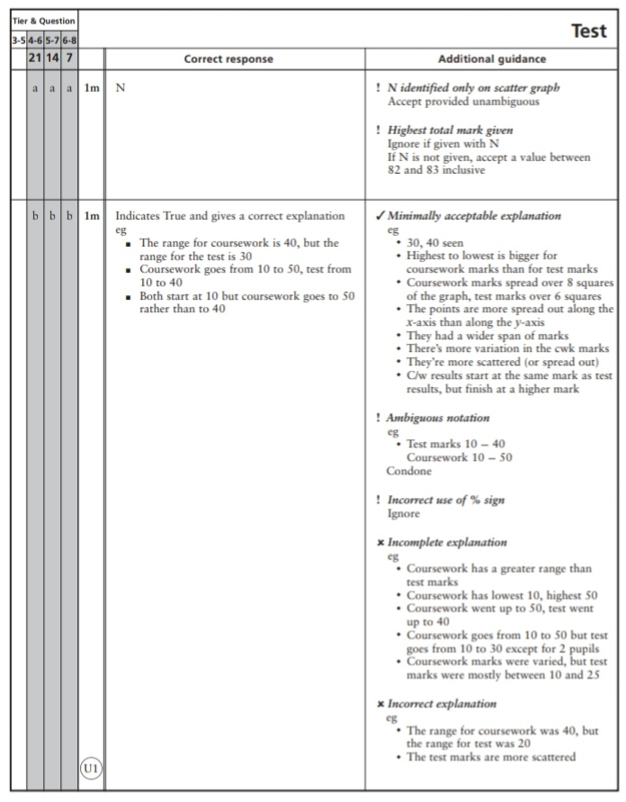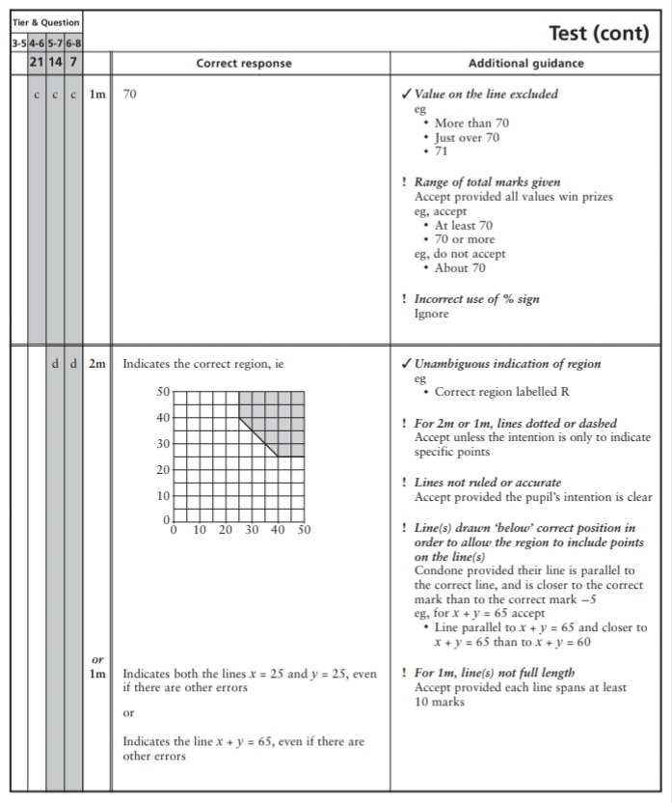
7.
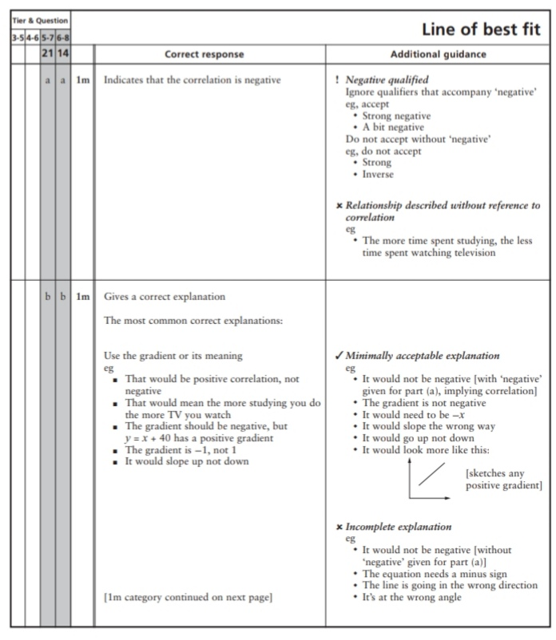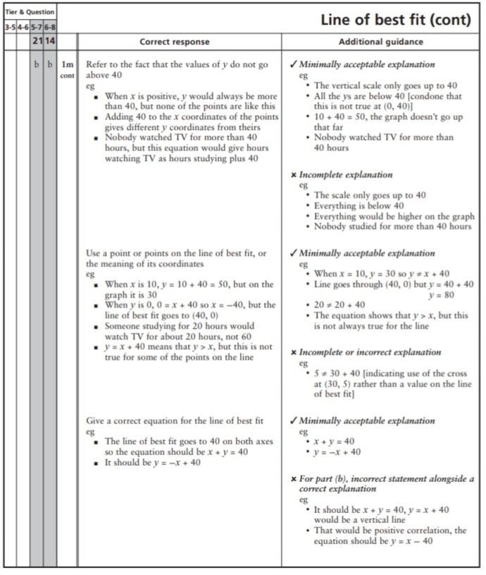
Key Stage 3: 2006 Paper 1 Level 6-8
8.
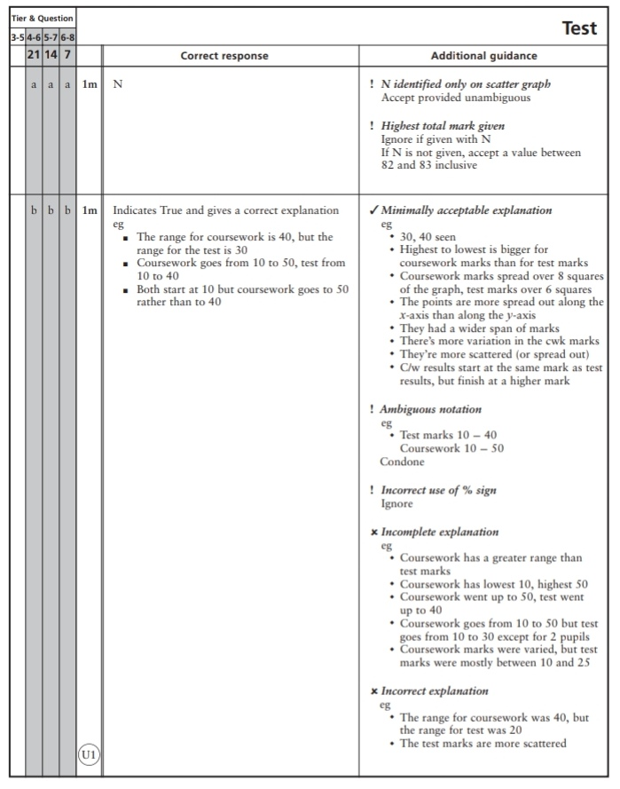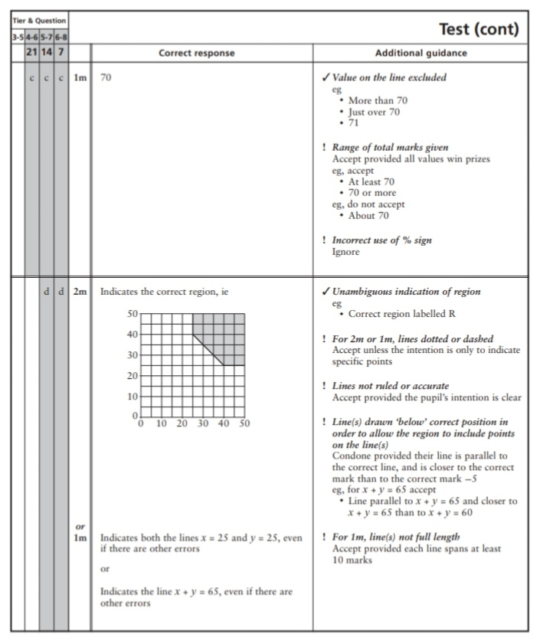
9.
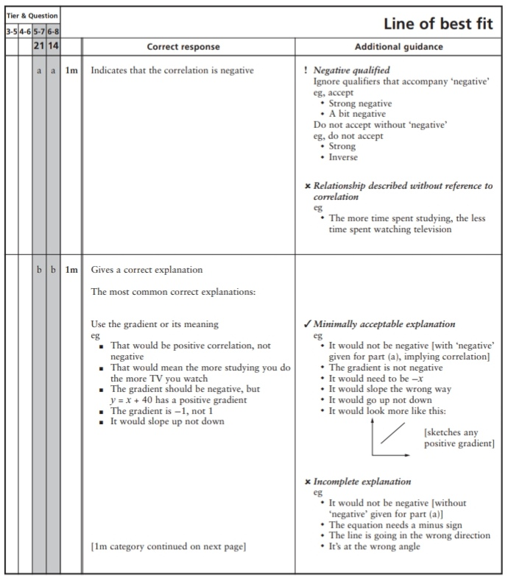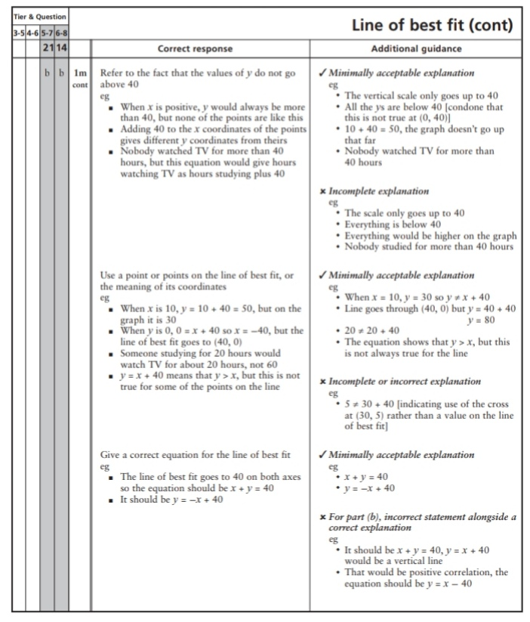
Key Stage 3: 2008 Paper 2 Level 5-7
10.
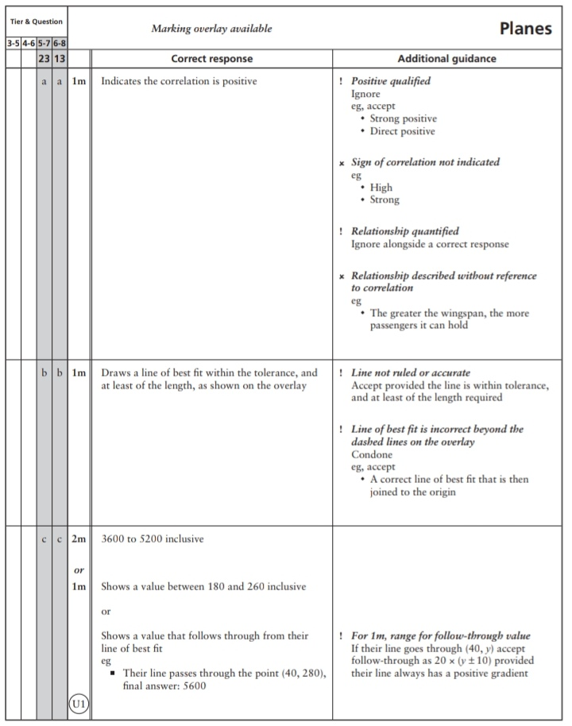
Key Stage 3: 2008 Paper 2 Level 6-8
11.
Key Stage 3: 2009 Paper 1 Level 5-7
12.
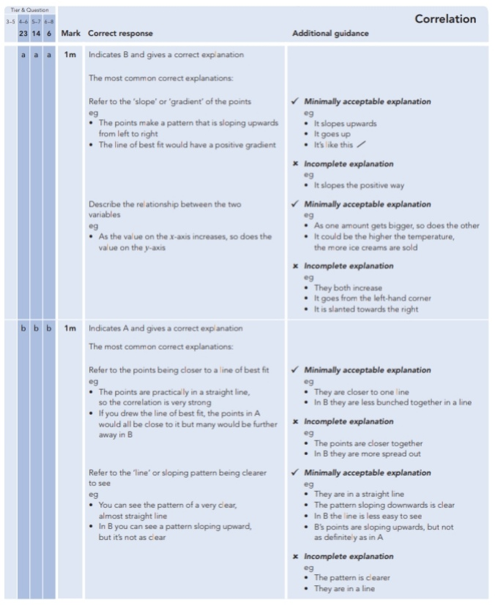
Key Stage 3: 2009 Paper 1 Level 6-8
13.
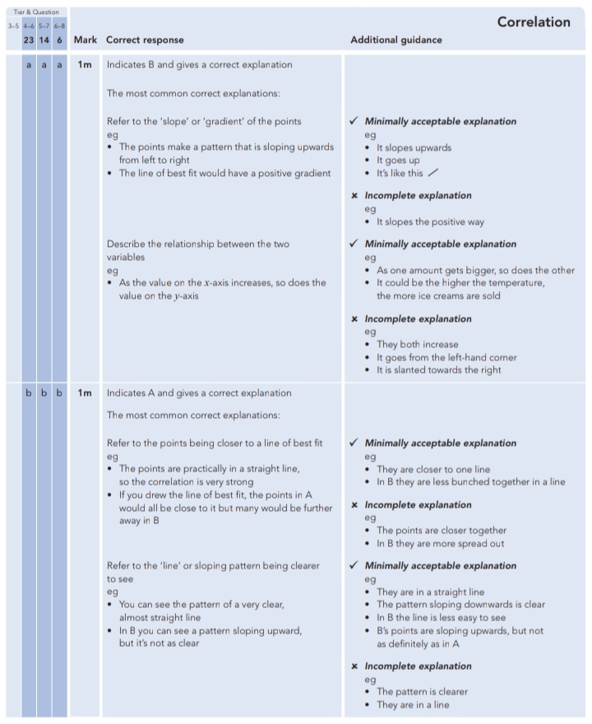
Key Stage 3: 2010 Paper 2 Level 5-7
14.
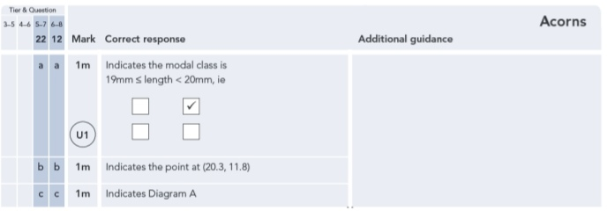
Key Stage 3: 2010 Paper 2 Level 6-8
15.
